№. 3  May, 2023  In the Issue:  About the project  - Activities  - Deliverables | 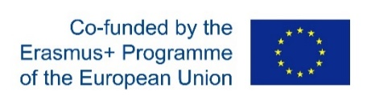  Newsletter  PROJECT IDENTIFICATION  Acronym: QFORTE (Enhancement of Quality Assurance in Higher Education System in Moldova)  Type of the project: National/Structural project  Total Budget: € 992.363,00  Project`s period: 15/11/2020 – 14/11/2023 (36 months)  Coordinating institution: Moldova State University  Link: https://qforte.usm.md/  Reference number:  (618742-EPP-1-2020-1-MD-EPPKA2-CBHE-SP)  This project is funded with the support of the European  Commission under the Erasmus+ Programme  №. 3  May, 2023  In the Issue:  - About the project  Activities  Deliverables  - Online Discussion Session- Joint Higher Education Programs  Moldova State University (USM), the coordinating institution of the QFORTE project, participated in a session organized by CEENQA, within the Erasmus+ project QFORTE (Enhancement of Quality Assurance in Higher Education System in Moldova-QFORTE), reference number: 617490- EPP- 1-2020-1-MD-EPPKA2-CBHE-SP, which aimed to discuss the practical issues of external quality assurance for joint higher education programs, which can be organized with both foreign and national universities.  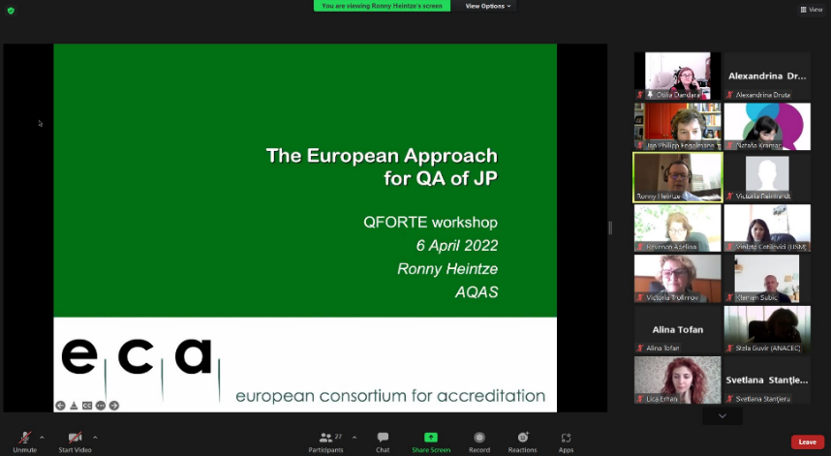  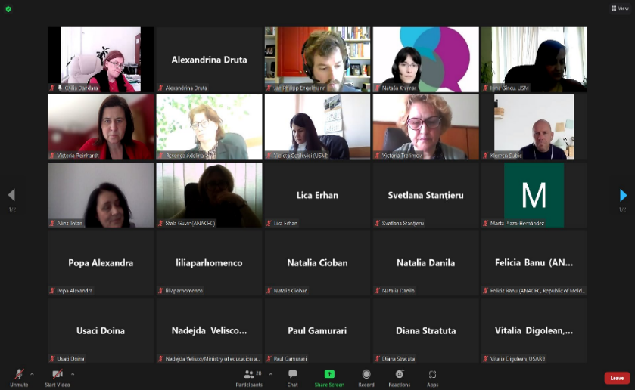  The event took place in online format on April 6, 2022, in which all partner universities from the Republic of Moldova and the EU (Germany, France, Spain and Slovenia), ANACEC and representatives of the Ministry of Education and Research of the Republic of Moldova participated. USM was represented by Ms. Otilia DANDARA, Deputy Rector, QFORTE project coordinator - Ms. Nadejda VELIȘCO, Ms. Irina GÎNCU, project manager, head of the Academic Studies Department, and members of the Quality Management Departmrent.  №. 3  May, 2023  In the Issue:  - About the project  Activities  Deliverables  During the session, Ronny Heintze, Deputy Director for International Development, German Agency for the Quality Assurance of Higher Education Programs (AQAS), spoke about the European approach to joint higher education programs, the challenges that may be encountered and the minimum requirements of the program.  The expert mentioned that "External quality assessment for accreditation is also subject to joint study programs of consortia/partnerships created by educational institutions in the country and abroad, of branches of educational institutions in the country or abroad, of consortia created by educational institutions together with research, development, innovation or artistic creation organizations, as well as by associations of educational institutions with legal entity status operating on the territory of the Republic of Moldova, based on a partnership contract, according to the legislation in force.  Higher education institutions participating in joint higher education programs will jointly select a quality assurance agency registered in the European Register for Quality Assurance in Higher Education (EQAR). The external quality assessment process for the provisional operation authorization/accreditation of the joint higher education program will be carried out according to the Procedure regarding the provisional operation authorization and accreditation of the joint higher education programs."  №. 3  May, 2023  In the Issue:  - About the project  Activities  Deliverables  - Development and adaptation of institutional quality assurance strategies  Moldova State University organized a seminar, within the Erasmus+ project, which aimed to present the draft strategies for institutional quality assurance and their subsequent approval. The event took place in online format on 25.05.2022, in which all partner universities from the Republic of Moldova participated (USM, ASEM, USARB, USC, KDU, AMTAP, USPEE). The seminar was chaired by the coordinator of the QFORTE project - Ms. Nadejda VELIȘCO. USM was represented by Mrs. Otilia DANDARA, Deputy Rector of USM, Mrs. Irina GÎNCU, head of the Academic Studies Department and members of the Quality Management Department.  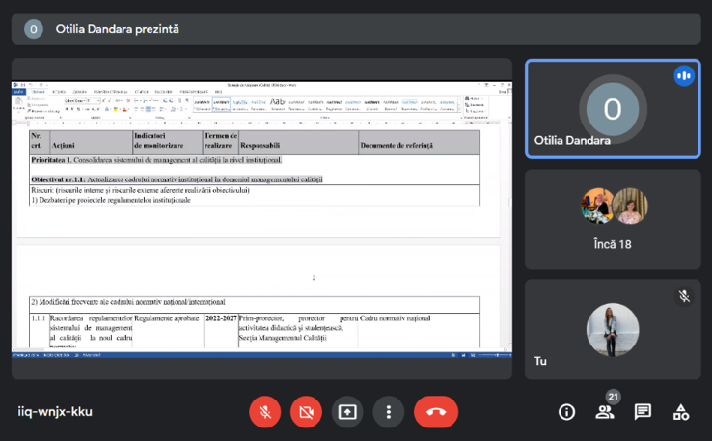  During the seminar, the preliminary versions of the institutional strategies for quality assurance of all the universities mentioned above were presented. The submitted Strategy projects had the following structure: introduction (where both the importance and the decisions that led to the development of the strategy, as well as the proposed period for implementation were indicated), the analysis of the situation (which presents a retrospective of the problems in the field of quality assurance), the objectives , the internal and external risks following the achievement of the objectives, the priority directions (which describe the activities planned for the proposed objectives), the long-term impact of these actions,  reporting procedures, monitoring and evaluation indicators through which the level of achievement of objectives is established, etc. The meeting was concluded by Mr. Andrei Chiciuc, President of ANACEC, who spoke about the selection of the QA agency for institutional accreditation.  №. 3  May, 2023  In the Issue:  - About the project  Activities  Deliverables  In the second part of the meeting, Andrei Chiciuc, President of ANACEC announced the results of the selection of the QA Agency for institutional accreditation. It was mentioned that there were six agencies that expressed their interest in the QFORTE proposal. After analyzing the proposals, all the partners agreed that the Romanian Quality Assurance Agency for Higher Education (ARACIS) is the most appropriate because of the cost-effectiveness, lack of language barriers and good knowledge and expertise of the Moldovan education system. At least five HEIs will be internationally externally evaluated for institutional accreditation.  Participants in the meeting had the opportunity to ask questions and provide feedback to colleagues.  №. 3  May, 2023  In the Issue:  - About the project  Activities  Deliverables  - Institutional quality assurance strategy  - 2022-2027  In the framework of the Project, institutional quality assurance strategies were developed, which aim to set up an effective quality management system, ensuring performance in the professional training process.  The basic objectives of this strategy consist of  - updating the institutional normative framework in the field of quality management;  - the use of modern educational and research technologies and the valorization of scientific achievements in the professional training process;  - increasing the level of transparency of information regarding internal quality management and, last but not least, recognition;  - the development the university curriculum from the perspective of internationalization and international appreciation. The monitoring of their implementation is carried out by the Quality Management Section.  The current Strategy is planned to be implemented through the annual organization of activities within the structures of the quality management system within the universities which will eventually be reflected in the Activity Plan of the Quality Management Section; Quality Council; Quality assurance commissions within the faculties; Office of Doctoral Schools.  The method of checking and ascertaining the results will be done by analyzing the activity reports, which are presented during the meetings of the Faculty Council or the Quality Council.  If, following the evaluation, it is necessary to implement some corrective measures, they will be included as a modification of the strategy, approved in the appropriate manner by the institution.  №. 3  May, 2023  In the Issue:  - About the project  Activities  Deliverables  №. 3  May, 2023  In the Issue:  - About the project  Activities  Deliverables  №. 3  May, 2023  In the Issue:  - About the project  Activities  Deliverables  №. 3  May, 2023  In the Issue:  - About the project  Activities  Deliverables  - The European Union's Erasmus+ program celebrated 35 years  The year 2022 marked the 35th anniversary of the EU Erasmus+ program for education, training, youth and sport. Since 1987 (the year of establishment), more than 12 million beneficiaries have participated in academic youth exchanges and projects to modernize and internationalize education around the world.  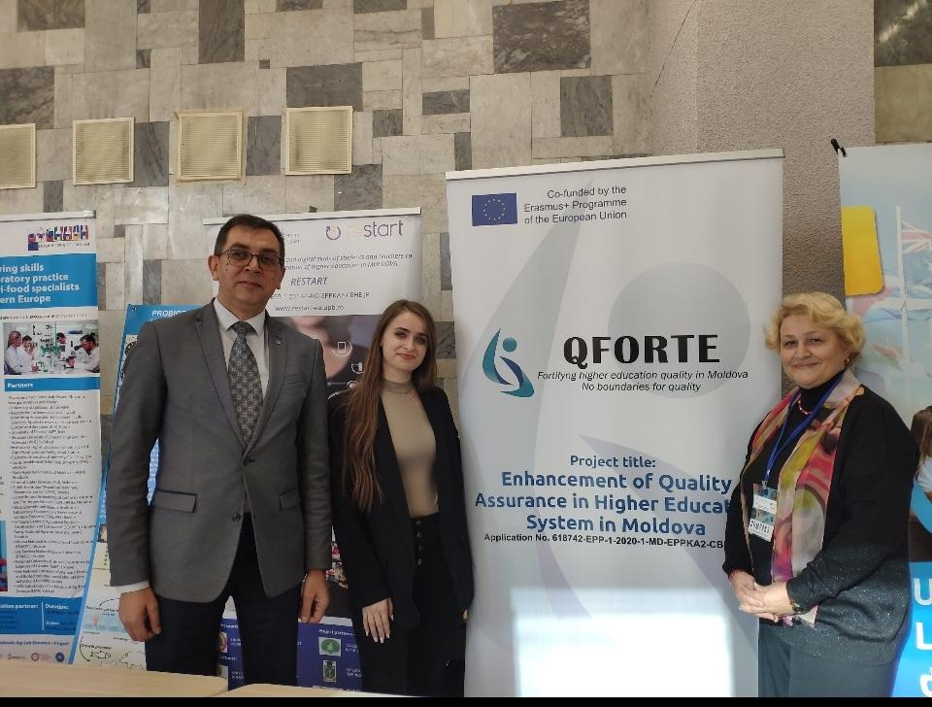  On the occasion of this anniversary, and within the framework of the European Year of Youth, the Erasmus National Office, together with the Delegation of the Republic of Moldova to the European Union and the Ministry of Education and Research of the Republic of Moldova, organized a festive event. Collected beneficiaries of the Erasmus+ program from Moldova. It was attended by students and young people, academics, representatives of ministries and NGOs. The purpose of the event was to promote the Erasmus+ program in Moldova, to give young people a voice and to provide a networking platform to build new partnerships within the Erasmus+ project.  The event took place on October 12 and included two parts: The first part of the event was held at Clasa Viitorului (Ion Creangă State Pedagogical University) and was dedicated to a heated discussions between the beneficiaries of the Erasmus+ program from Moldova (students, young people, academics) and the Erasmus+ Project Fair. The second part took place in the Organ Hall and offered participants a classical music concert performed by students.  №. 3  May, 2023  In the Issue:  - About the project  Activities  Deliverables  №. 3  May, 2023  In the Issue:  - About the project  Activities  Deliverables  - The fourth meeting of the project consortium  Erasmus+  Moldova State University hosted the fourth Consortium of the Erasmus+ Project "Enhancement of Quality Assurance in Higher Education System in Moldova - QFORTE.  The event was attended by: Dr. Nadejda VELIȘCO, coordinator of the "QFORTE" Project, Otilia Dandara, Deputy Rector of USM, representatives of higher education institutions from the Republic of Moldova, local partners of the project and representatives of the European Union's partners.  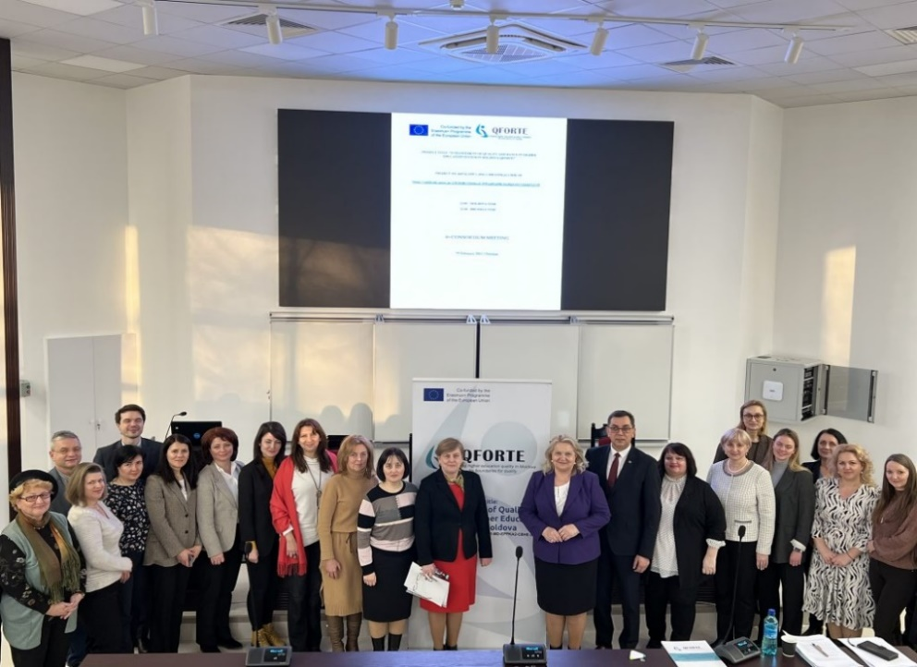  During the event, representatives of the National Agency for Quality Assurance in Education and Research (ANACEC) and the Ministry of Education and Research (MEC) presented the "e-form for QA self-evaluation report" concept, as well as information about the planning period of the 3 seminars for evaluators. In the same way, ANACEC presented the ARACIS Methodology for the external institutional evaluation/the respective guide. For their part, the national institutions participating in the project reported on the current situation of the implementation of the Quality Assurance Strategies, on the seminars organized following the study visits and on the existence of the quality assurance structures.  №. 3  May, 2023  In the Issue:  - About the project  Activities  Deliverables  At the end, the participants discussed and outlined the new objectives of the Project. The Moldova State University is the coordinator of the project "Improving Quality Assurance in the Higher Education System of Moldova", which aims to promote and strengthen the culture of quality assurance in the Republic of Moldova.  №. 3  May, 2023  In the Issue:  - About the project  Activities  Deliverables  - Clustering  On April 28, 2023, in the premises of the Moldova State University, central building, room 137, the joint meeting of the institutional teams of the structural CBHE project 618742-EPP-1-2020-1-MD-EPPKA2-CBHE-SP took place Enhancement of Quality Assurance in Higher Education System in Moldova – QFORTE in the context of the preparation for the cluster meeting, to be organized by the Erasmus+ National Office from Moldova on May 17, 2023.  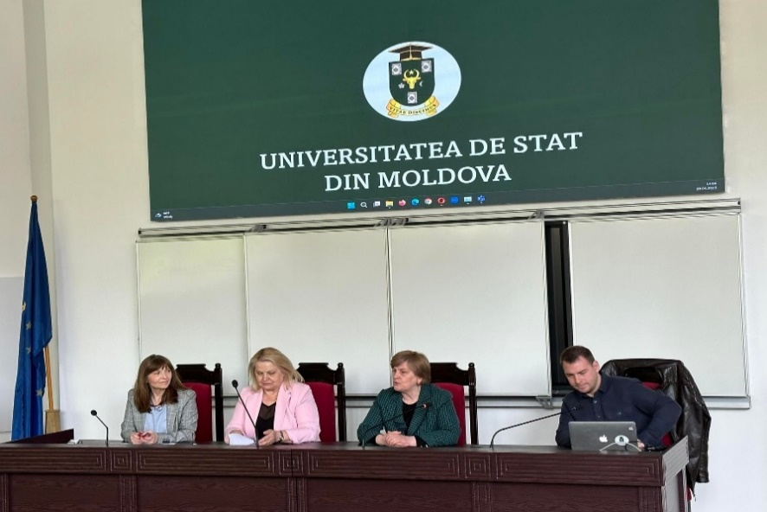  The meeting was opened with a welcome speech by Mrs. Otilia DANDARA, Deputy Rector of the Moldova State University and Nadejda VELIȘCO, national coordinator of the QFORTE project. After all the project's institutional coordinators presented the results of the implementation of the provisions of the QFORTE project in each of their institutions, the dissemination report by ASEM was vividly presented, in which the impacts and results of the structural project at the national and institutional level were highlighted.  №. 3  May, 2023  In the Issue:  - About the project  Activities  Deliverables  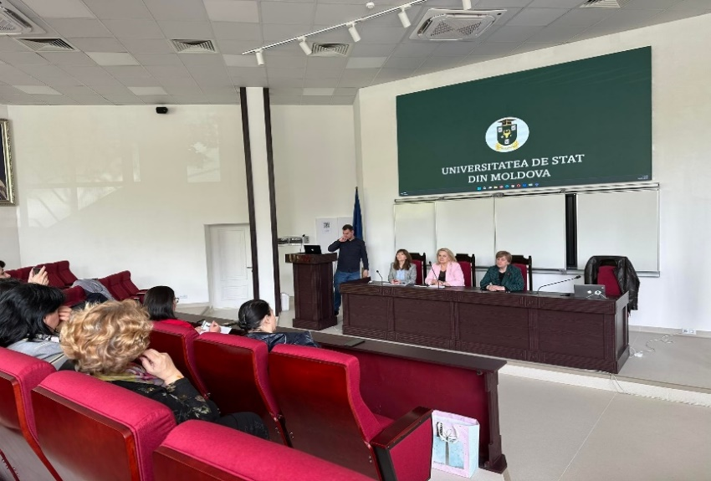  At the end, the participants engaged in a short dialogue where the questions raised during the presentations were discussed and some conclusions and recommendations were drawn.
3rd Newsletter  QFORTE project  №. 3  May, 2023 | More information about project activities can be found on:  - The official site of QFORTE: https://qforte.usm.md/  - QFORTE project links of partner universities:  https://mec.gov.md/ro/content/erasmus  https://anacec.md/ro/projects  https://uspee.md/proiecte/qforte/  https://bri.ase.md/enhancement-of-quality-assurance-in-higher-education-system-in-moldova-qforte/  https://kdu.md/ru/nauka-i-mezhdunarodnye-svyazi/proekty/proekt-qforte  https://amtap.md/ro/qforte/  https://www.ceenqa.org/projects/qforte-enhancement-of-quality-assurance-in-higher-education-system-in-moldova/.  https://epdri.com/index.php/projects/  https://bisite.usal.es/es/investigacion/proyectos/internacionales  https://usarb.md/despre-qforte/  https://proiecte.usch.md/despre-qforte/  https://www.sozphil.uni-leipzig.de/fakultaet/studienbuero/#collapse593141  https://www.umontpellier.fr/international/projets-internationaux  Contacts:  Address: 60, Al. Mateevici str. MD-2009 Chisinau, Republic of Moldova  Email: qforte.project@usm.md  Phone number: +373 67-316-317  The contents of this publication are the sole responsibility of Moldova State University and do not necessarily reflect the opinion of the European Union.

