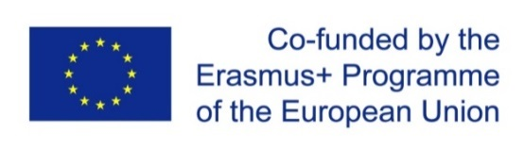
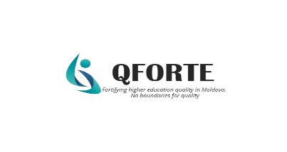
ONLINE MEETING WITH REPRESENTATIVES OF THE WORKING GROUPS OF THE PARTNER UNIVERSITIES IN THE QFORTE PROJECT
25 May, 2022
Subject: Development, adoption of institutional QA strategies
Leader: organized by the activity leader USM
Reference: WP3/ D3.1/ A3.1.5

Moldova State University organized an online meeting, within the framework of the Erasmus+ project Enhancement of Quality Assurance in Higher Education System in Moldova - QFORTE, reference number: 617490-EPP-1-2020-1-MD-EPPKA2-CBHE-SP, presided by Nadejda Velișco, QFORTE Grant Coordinator. The aim of the meeting was the presentation and discussion of drafts of institutional quality assurance strategies for their subsequent approval. The online discussion was held on 25 May, 2022 and was attended by all partner universities from the Republic of Moldova and ANACEC President and representatives.
Drafts of the institutional QA strategies have been presented by the Vice-Rectors for Education or Heads of QA departments, thus exchanging experience and best practices. All partners agreed that in spite of the fact that there have been identified a lot of institutional regulations on quality assurance, there is an evident lack of a strategic institutional document that would cover all levels of an institution, with indicators of performance and detailed action plans.
The QA strategies follow the agreed structure: introduction (indicating both the importance and the decisions that led to the elaboration of the strategy and the proposed period of implementation), situation analysis (presenting a retrospective of the problems in the field of quality assurance), objectives, internal and external risks in achieving the objectives, priority directions (describing the activities planned to achieve the proposed objectives), long-term impact of these actions, reporting procedures, monitoring and evaluation indicators through which the level of achievement of the objectives is determined.
Considerable amount of time was dedicated to the strategy implementation risks. It was stressed that anticipating the risks is of really great importance for the institutional strategic development and necessary measures should be taken to diminish the effects of the risks.
In the second part of the meeting, Andrei Chiciuc, President of ANACEC announced the results of the selection of the QA Agency for institutional accreditation. It was mentioned that there were six agencies that expressed their interest in QFORTE proposal. After analyzing the proposals, all the partners agreed that the Romanian Quality Assurance Agency for Higher Education (ARACIS) is the most appropriate because of the cost-effectiveness, lack of language barriers and good knowledge and expertise of Moldovan education system. At least five HEIs will be internationally external evaluated for institutional accreditation.
Participants in the meeting had the opportunity to ask questions and provide feedback to colleagues.

