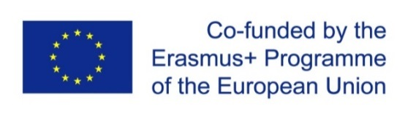

Project title: QFORTE - Enhancement of Quality Assurance in Higher Education System in Moldova (Ref. nr.: 618742-EPP-1-2020-1-MD-EPPKA2-CBHE-SP)

https://qforte.usm.md
6 th CIRCULAR LETTER

Subject: Development, adoption of institutional QA strategies
Leader: organized by the activity leader USM
Reference: WP3/ D3.1/ A3.1.5

Dear QFORTE National Partners,
For the purpose of completing the drafts of the Institutional QA Strategies within the QFORTE Project (WP3/ D3.1/ A3.1.5), I invite you to an online meeting with the representatives of the working groups of the partner universities on 25 May 2022 (14.00-16.00).
In this context, I kindly ask the QFORTE institutional coordinators to ensure the presence of a person from the UQA working group and the Vice-Rector responsible for quality assurance from each university to present their draft QA strategies.
Meeting link: https://meet.google.com/iiq-wnjx-kku
The meeting will focus on the presentation of the drafts of the Institutional QA Strategies and their subsequent approval.

Yours faithfully,
Dr. Nadejda Velisco, QFORTE Coordinator

AGENDA
25 May 2022 ONLINE session
14.00 - 16.00
Estern European Summer Time
14:00 | Welcome speech  Nadejda Velisco, QFORTE coordinator
14:15-15.30 | - Presentation of the draft versions of the institutional strategies QA  - Moldova State University (USM)  - Academy of Economic Studies of Moldova (ASEM)  - Balti State University (USARB)  - Cahul State University (USC)  - Comrat State University (KDU)  - Academy of Music, Theatre and Fine Arts (AMTAP)  - University of Political and Economic European Studies (USPEE)
15:30-16.00 | - Selection of QA Agency for institutional accreditation  ANACEC
16:00 | Questions & Discussions

