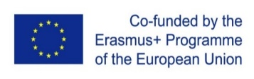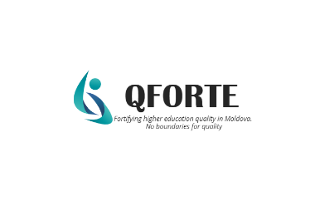
Seminar on international institutional accreditation within the Erasmus+ project QFORTE (Leipzig University, 29-30 March 2022)
A seminar on international institutional accreditation was organized by the University of Leipzig, Germany, in the framework of the Erasmus+ project Enhancement of Quality Assurance in Higher Education System in Moldova- QFORTE, reference number: 617490-EPP-1-2020-1-MD-EPPKA2-CBHE-SP. The seminar was held online on 29-30 March and was attended by representatives of the Ministry of Education and Research from the RM, ANACEC, Moldovan partner universities and the EU project partners (Germany, France, Spain and Slovenia).
Dr. Victoria Reinhardt, Director of the Study Office and Curriculum Management Department, Faculty of Social Sciences and Philosophy, University of Leipzig and Dr. Nadejda Velișco chaired the seminar, within which discussions were held about the international institutional accreditation, procedures and methodologies.
During the session, Anja GRUBE, representative of the Central Evaluation and Accreditation Agency (ZevA) and Sonja MIKESKA, Quality Assurance expert (FH Münster) shared their experience about the international institutional accreditation, namely the legal framework, concept, methodology, procedures and best practices. In this context, the participants discussed the issues and challenges related to the ultimate goal of the QFORTE project for the Republic of Moldova - institutional accreditation.
The session continued with the presentation of Nora SKABURSKIENE, Head of Quality Management Department, Vilnius Gediminas Technical University, who presented the experience of Lithuanian higher education institutions in the field of international accreditation. The participants were informed about managerial, organizational, financial and intercultural difficulties in the process of international institutional accreditation. The advantages and benefits have been mentioned as important factors for institutional development.
The event ended with a round table discussion on international accreditation for higher education institutions in the Republic of Moldova namely: legal framework, requirements, objectives, funding conditions, possible scenarios and challenges.

