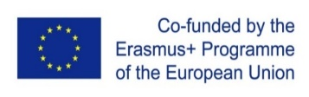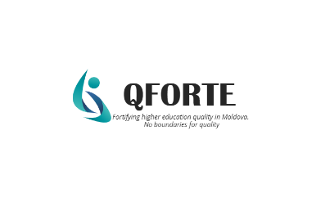
ONLINE DISCUSSION SESSION – JOINT STUDY PROGRAMMES
6 April, 2022
CEENQA (Central and Eastern European Network of Quality Assurance Agencies) organized a discussion session in the framework of the Erasmus+ project Enhancement of Quality Assurance in Higher Education System in Moldova- QFORTE, reference number: 617490-EPP-1-2020-1-MD-EPPKA2-CBHE-SP, in order to discuss practical issues of external quality assurance of joint study programmes. The online discussion was held on 6 April, 2022 and was attended by all partner universities from the Republic of Moldova and the EU (Germany, France, Spain and Slovenia), ANACEC and representatives of the Ministry of Education and Research (MEC).
The draft of the Procedure for the authorization of provisional operation and accreditation of joint study programmes, elaborated by the ANACEC was presented and discussed, following the European regulations of external evaluation of the quality of joint programmes at all levels.
In the first part of the session, ANACEC and MEC representatives discussed practical aspects of external quality assurance of joint study programmes with the expert Klemen ŠUCIC, Head of the Department for Quality Assurance and International Cooperation at the Slovenian Quality Assurance Agency - NAKVIS. Taking into account the interest of partner institutions from the RM in the procedure, there were examined issues related to the consortia, contents of the evaluation dossier and standards for quality assurance.
In the second part of the session, Ronny HEINTZE, Deputy Director for International Development at the German quality assurance agency AQAS, spoke about the European approach to external quality assurance of joint study programmes. The presentation included aspects related to common European practices of joint programmes evaluation – descriptions of the procedure, responsibilities, terms, challenges and difficulties during the site visits.
The session continued with a round of discussions between Moldovan and European partners. As a result of this session, the draft of the Procedure for the authorization of provisional operation and accreditation of joint study programmes will be completed and adapted to the recommendations of the European framework and the experience of the partner institutions, and will then be submitted for public discussion and approval according to the project timeline.

