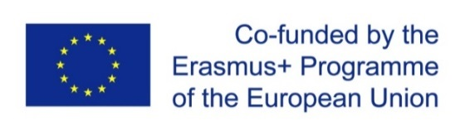 Project title: “ENHANCEMENT OF QUALITY ASSURANCE IN HIGHER EDUCATION SYSTEM IN MOLDOVA-QFORTE”
Project No. 618742-EPP-1-2020-1-MD-EPPKA2-CBHE-SP
14-16 March 2022, Chisinau
Online Study Visit at the Leipzig University
Moldova State University, the coordinating institution within the Erasmus + project, QFORTE Enhancement of Quality Assurance in Higher Education System in Moldova (reference number 617490-EPP-1-2020-1-MD-EPPKA2- CBHE-SP) participated at the online study visit at the University of Leipzig, Germany.
The event took place between 14 -16 March 2022 and was attended by the representatives of the Ministry of Education and Research, ANACEC and project partner universities from the Republic of Moldova, Germany, France, Spain and Slovenia. Moldova State University was represented by the Vice-rector Otilia Dandara, institutional coordinator Irina Gîncu, members of the MSU Council on Quality Management.
Prof. Dr. Thomas Hofsäss, Vice-rector for Education and International Relations at the University of Leipzig welcomed the partners and mentioned the importance of the QA system for a HEI. Denis Keune and Dr. Christina Taube developed the topic of quality management at the University of Leipzig, namely the accreditation system and the introduction of QA system in the Development Strategy of the University of Leipzig, actors and structures for quality assurance and evaluation and certification of university diplomas.
Dr. Victoria Reinhardt and Stephan Kaschner from the Study Office of the Faculty of Social Sciences and Philosophy, University of Leipzig presented a deep analysis of the Quality Management system within the Faculty of Social Sciences and Philosophy, and the process of development, evaluation of national and international study programmes, the accreditation of joint study programmes.
Another topic discussed was the process of international accreditation by the Association to Advance Collegiate Schools of Business (AACSSB) at the Faculty of Social Sciences and Philosophy of the University of Leipzig, presented by Prof. Dr. Gregor Weiss.
The study visit ended with a round table where the participants reported on the institutional development strategies in the field of Quality Assurance, elaboration of drafts, main objectives and outcomes, action plans and the steps to be taken according to the QFORTE operational plan.
More details about the QFORTE on the official project website: www.qforte.usm.md

