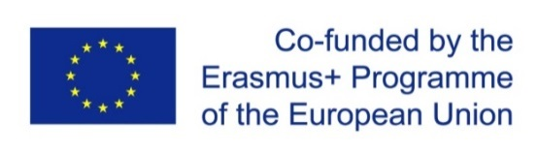
Project title: “ENHANCEMENT OF QUALITY ASSURANCE IN HIGHER EDUCATION SYSTEM IN MOLDOVA-QFORTE”
Project No. 618742-EPP-1-2020-1-MD-EPPKA2-CBHE-SP
11th March 2022, Chisinau
ONLINE session
14.00 - 18.00 EEST / 13:00 – 17:00 CET
3 ^{rd} Consortium meeting

The 3rd Consortium meeting within the Erasmus + project “Enhancement of Quality Assurance in Higher Education System in Moldova - QFORTE” was held on 11 March 2022, in online format.
The meeting was led by Nadejda Velișco, QFORTE Project coordinator. The event was attended by representatives of higher education institutions from the Republic of Moldova, local project partners and representatives of European Union partners.
During the event, the work packages and their level of implementation were reported and analyzed. Some new objectives of the project were also outlined, including some updates to the work packages, which are responsible for increasing the institutional capacity in order to implement the study quality assurance (QA) reform and project management. It was agreed that the tasks for the second project year are of great importance, especially elaboration and adoption of QA tools, ammendments to the Code of Education and recommendations for reforming the national Methodology on institutional QA accreditation.
Moldova State University is the coordinator of the project and that the main purpose of the project is “Improving Quality Assurance in the Higher Education System of Moldova”. It aims to promote and strengthen the culture of quality assurance in the Republic of Moldova; to build the national consensus on development issues by November 2023; to develop and promote the national legislative framework and to stimulate regulatory changes regarding quality assurance in higher education institutions in Moldova by November 2023.
Local partners:
- State University of Moldova (USM) - coordinator
- Ministry of Education and Research of the Republic of Moldova (MERRM)
- National Agency for Quality Assurance in Education and Research (ANACEC)
- Academy of Economic Studies (ASEM)
- Academy of Music, Theater and Fine Arts (AMTAP)
- “Alecu Russo” State University of Bălți (USARB)
- Cahul State University (USC)
- Comrat State University (KDU)
- “Constantin Stere” University of European Political and Economic Studies (USPEE).
EU partners:
- University of Montpellier, France (UM)
- University of Salamanca, Spain (USAL)
- University of Leipzig, Germany (ULEI)
- Institute for European Policy Development and Research in Maribor, Slovenia (EPDRI)
- Network of Central and Eastern European Quality Assurance Agencies (CEENQA)

