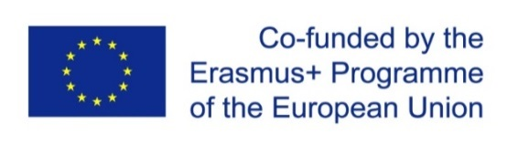
Project title: “ENHANCEMENT OF QUALITY ASSURANCE IN HIGHER EDUCATION SYSTEM IN MOLDOVA-QFORTE”
Project No. 618742-EPP-1-2020-1-MD-EPPKA2-CBHE-SP
11th March 2022, Chisinau
ONLINE session
14.00 - 18.00 EEST / 13:00 – 17:00 CET
2nd COUNTRY WORKSHOP
Moldova State University organized the 2nd Country Workshop within the Erasmus + project "Enhancement of Quality Assurance in Higher Education System in Moldova - QFORTE", (618742-EPP-1-2020- 1-MD-EPPKA2-CBHE-SP) on 11th of March 2022. The main topic of discussion related to the dialogue on national policy and development of institutional Quality Assurance system.
The meeting was led by Nadejda Velișco, QFORTE Project coordinator. The event was attended by representatives of higher education institutions from the Republic of Moldova, local project partners and representatives of European Union partners.
It was stated that one of the main objectives of the project is the integration of the Republic of Moldova in SEIS/ EHEA (European Higher Education Area) by improving quality assurance in the higher education system.
Jan Philipp ENGELMANN and Natasa KRAMAR (CEENQA) presented a deep analysis of the current internal quality assurance systems at higher education institutions in the Republic of Moldova. The country profile of the HEIs in the Republic of Moldova included the analysis of the general concepts of quality assurance, QA strategies and policies, quality of programmes, QA procedures, the role of MEC and ANACEC and the main issues and challenges to be addressed.
Recommendations for reforming the national Methodology on institutional QA accreditation were presented by ANACEC and representatives of CEENQA. It is important that some of the amendments have already been approved, although there can be identified areas of improvement related to the state control, accreditation of some programmes, the relation between programme accreditation and institutional accreditation.
Amendments to the Code of Education of the Republic of Moldova and the implementation stage was analyzed by Lilia PARHOMENCO, Senior Consultant at the Ministry of Education and Research of the Republic of Moldova. The Ministry of Education and Research will promote the improvement of accreditation procedure of joint programmes, doctoral programmes and schools and accreditation validity.

