Study Visit to the University of Montpellier within the QFORTE Project
On 18-22 October, 2021, within the QFORTE project (Enhancement of Quality Assurance in Higher Education System in Moldova, reference number: 618742-EPP-1-2020-1-MD-EPPKA2-CBHE-SP) representatives from PCUs, Ministry of Education and Research, ANACEC visited the University of Montpellier, France. The main goal of the event was to ensure the transfer of the best practices of the University of Montpellier in introducing various models of QA strategy development at university level. These practices are of great importance for internal and external quality assessment systems and for institutional accreditation. Taking into account the COVID-19 restrictions, the event was organized in a hybrid format.
Moldova State University, the coordinating institution was represented by Mrs. Otilia Dandara, Vice Rector for Academic Affairs, Irina Gîncu, Head of the Department of Studies and Maria Hămuraru, the Dean of the Faculty of Economic Sciences.
The programme of the study visit included topics on:
- Information on the French QA framework, national institutional accreditation procedures and external evaluation;
- Organization of the internal QA process within the French universities;
- Institutional QA strategies of the University of Montpellier, the tools and methodology applied;
- French experience in completing the processes of accreditation of study programmes and institutional accreditation.
A topic of major interest for the participants of the study visit were the indicators for monitoring the internal processes of the University of Montpellier in terms of the impact on the performance of university management and the placement of the university in international rankings. It was mentioned that QA and the monitoring processes at the University of Montpellier are based on the holistic approach, being carried out within the implemented projects.
Mr. Patrick Caron, UM Vice-president for International Relations and Ms. Celine Delacourt – Gollain, Head of International Relations Department welcomed the participants of the study visit and presented a short description of the University of Montpellier, the youngest medieval university. In this presentation it was mentioned the university's strategy for creating a thematic research-intensive university, which will be recognized internationally for its impact on agriculture, environment and health.
During the study visit, the university's development strategy was mentioned, which consists in promoting partnerships with the most famous universities in Europe and other non - EU countries. The expected results are new academic opportunities for students, more accessible studies and the increase the university's attractiveness.
Also, UM institutional quality assurance strategies were discussed, the tools and the action plan were presented by Ms. Sylvie Narejos, Head of Quality Department. In addition, the French national institutional accreditation and external evaluation procedures were examined and presented by Ms. Nadia Lagarde.
All participants agreed that experiencing this type of exchange visits contributes to the mutual knowledge and maintenance of collaborative relations between international and local partners, which is an exceptional experience that opens new academic opportunities and contributes to the improvement of internal insurance processes of the quality of studies at the Moldova State University. Thus, detailed knowledge of university systems in the European Union will certainly bring the Republic of Moldova closer to the European Higher Education Area (EHEA).
Moldova State University, the coordinating institution would like to thank the colleagues from the UM for their continued support and generosity during in the study visit. We extend deep gratitude and thanks for all efforts of our colleagues from the University of Montpellier:
Dr. Patrick Caron, Vice-President for International Relations
Dr. Céline Delacourt-Gollain, Head of International Relations Department
Dr. Manon Martinez, QFORTE Project Manager
Dr. Guilhem Culotte, Head of the Management Control and Performance Analysis Department
Dr. Sylvie Narejos, Head of the Quality Department
Dr. Irène Georgescu, Montpellier Management School Professor in charge of professionalization and accreditations
Dr. Nadia Lagarde, Deputy Head of the International Relations Department and Quality Assurance European Expert
Dr. Autcharaporn Somsing, Montpellier Institute of Business Administration Head of International Accreditation
Dr. Elliott Chollet, Project Manager
Dr. Roisin Smith, CHARM-EU Quality Officer
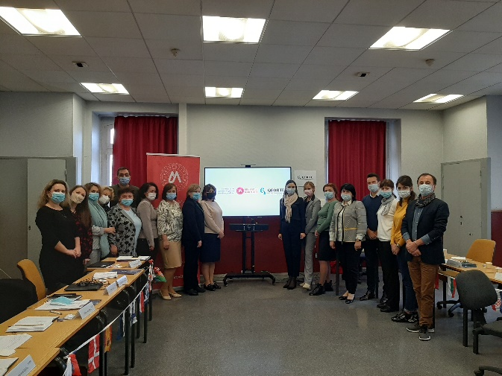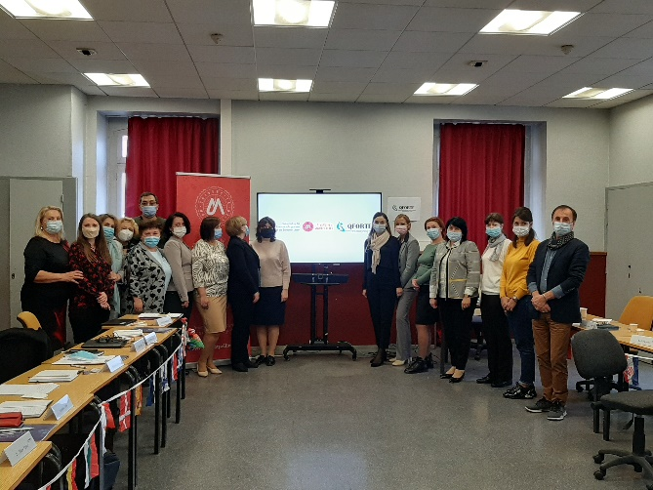
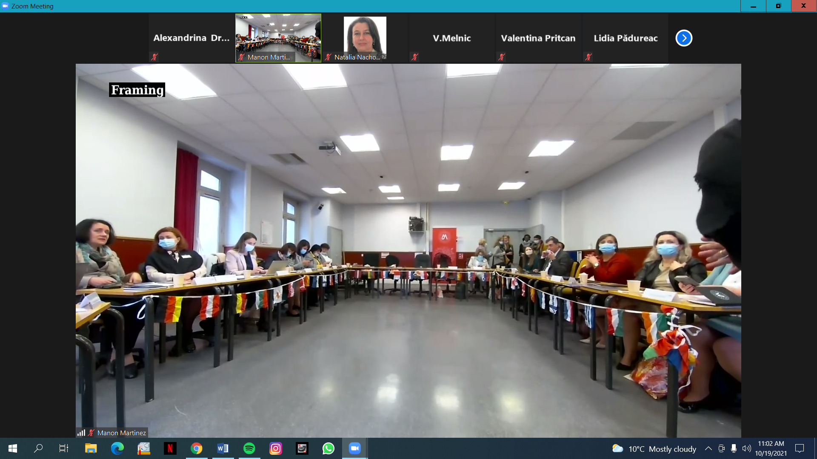

The contents of this publication are the sole responsibility of Moldova State University and do not necessarily reflect the opinion of the European Union.

