Study visit to the University of Salamanca - a good practice activity on institutional accreditation within the QFORTE project

A study visit to the University of Salamanca, Spain, hosted by the BISITE research group, within the project QFORTE (Enhancement of Quality Assurance in Higher Education System in Moldova, reference number: 618742-EPP-1-2020-1-MD -EPPKA2-CBHE-SP) was organized during the period of 8 - 10 of November 2021. The event is an initiative promoted by the Erasmus + Programme, co-financed by the European Union and coordinated by Moldova State University.
The purpose of the visit was to study and research the ways for improving the quality of studies in higher education institutions in the Republic of Moldova through strategies used in the European space, as well as the exchange of good practices on institutional accreditation. The meeting was held in hybrid format due to restrictions imposed by the COVID-19 pandemic.
Moldova State University was represented by Ms. Irina Gîncu - Head of the Department of Studies, Ms. Georgeta Stepanov- Dean of the Faculty of Journalism and Communication Sciences and Ms. Violeta Cotilevici - Head of Curriculum Development Unit.
The program of the visit included topics on:
- Characteristics of the Spanish national quality assurance framework, national institutional accreditation procedures and external evaluation;
- Principles, process and organization of the internal quality assurance process within the Spanish universities;
- Institutional quality assurance strategies of the University of Salamanca, the tools and methodology applied;
- Spanish experience in completing the process of accreditation of study programmes, but also of institutional accreditation.
The meeting was opened by Mr. José Miguel Mateos Roco, Vice-Rector for Research and Knowledge Transfer of the University of Salamanca, accompanied by Mr. Salvador Rus Rufino, Director of the Castilla y León Community Quality Agency and the Representative of the VISIT Group Mr. Juan M. Corchado Rodríguez with a greeting message.

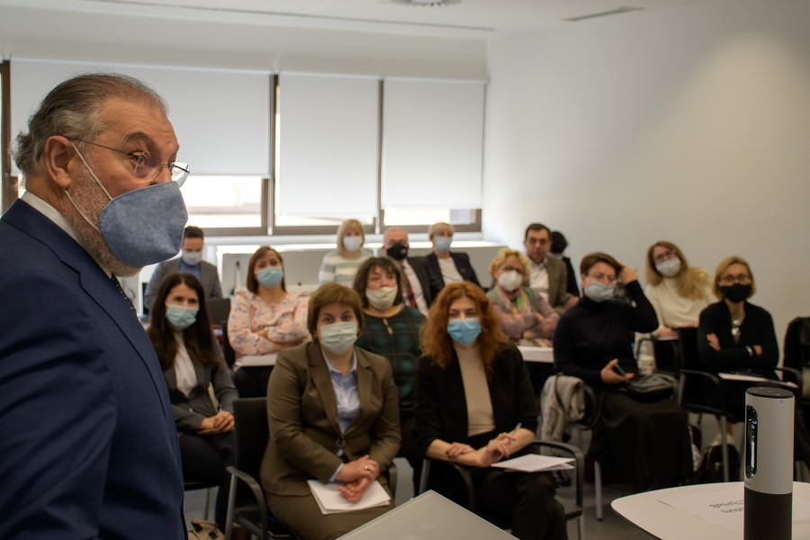
Dr. Salvador Rus Rufino, Director of the Community Quality Agency of Castilla y León
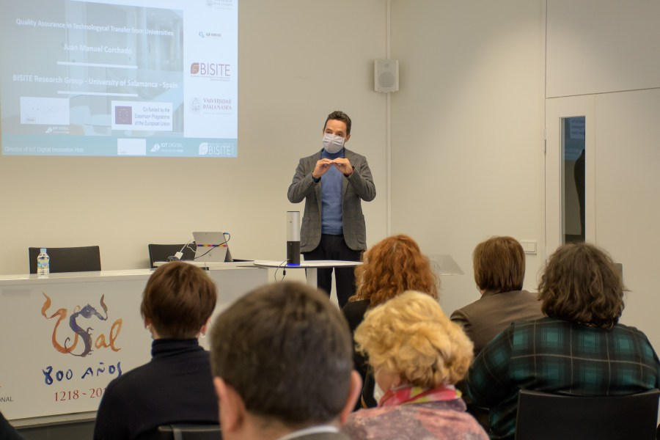
Dr. Juan M. Corchado Rodríguez, Representative of the VISIT Group
The Agency for the Quality of the University System Castilla y León (ACSUCYL) and the National Agency for Evaluation and Accreditation of Quality (ANECA), whose aim is to contribute to the improvement of the quality in the higher education system, were presented during the event. This takes place through evaluation, certification and accreditation of all research fields and institutions, as well as the evaluation and certification of academics.
Mateos Roco, in his speech, emphasized that quality assurance has become a way to formalize the communication and to equalize different education systems, providing an adequate, stable and secure framework for the exchange of knowledge, research and human resources.
Mr. Juan Manuel Corchado presented the quality assurance process at the University of Salamanca mentioning the innovation methodologies and the five steps for strategic innovation planning, followed by the ANECA representative who reported on the national accreditation framework in Spain and on the evaluation of Spanish higher education institutions. The procedure was described as a complex one, consisting of three stages: self- evaluation, a visit by a group of experts and evaluation for accreditation.
During the study visit, there were discussed the methods of evaluation and accreditation of higher education programmes (Cycle I - Bachelor, Cycle II - Master, Cycle III - Doctorate), institutional accreditation and teacher evaluation. In addition, the institutional system of surveys, suggestions and complaints were presented.
The study visit ended with a communication on the evaluation of scientific publications and the evaluation of research activities followed by a round table where good practices in the field of quality assurance were discussed.
Moldova State University, the QFORTE coordinating institution, expresses its gratitude to all the organizers who were actively involved in the study visit. Therefore, we are grateful and appreciate the efforts of:
Dr. José M. Mateos Roco,
Dr. Salvador Rus Rufino,
Dr. Juan M. Corchado Rodríguez,
Dr. José Antonio Cordón García
Dr. Enrique Herrera Viedma,
Dr. Ana Belén Gil, Marta Plaza,
Dr. Pablo Oñate Rubalcaba,
María José Echeverría Cubillas,
Sandra Blanco González,
Lucía Duarte Álvarez,
Felipe José Lorenzo Blanco.

